**Nagios 4.0.1 Released – Install on RHEL/CentOS 6.x/5.x and Fedora 19/18/17**

**Nagios** is an awesome **Open Source** monitoring tool, its provides you more comprehensive monitoring environment to always keep an eye on your all **machines** / **networks** whether you are in a your data center or just your small labs.

With **Nagios**, you can monitor your remote hosts and their services remotely on a single window. It shows **warnings** and **indicates** if something goes wrong in your **servers** which eventually helps us to detect some problems before they occur. It helps us to reduce **downtime** and **business losses**.

Recently, **Nagios** released its latest versions **Nagios 4.0.1** on **15th October 2013**, and its latest stable release of **Nagios plugins 1.5**.

This article is intended to guide you with easy instructions on how to install latest **Nagios 4.0.1** from source (tarball) on **RHEL 6.4/6.3/6.2/6.1/6/5.8**, **CentOS 6.4/6.3/6.2/6.1/6/5.8** and **Fedora 19,18,17,16,15,14,13,12** distributions. Within **30 minutes** you will be monitoring your local machine, no any advanced installation procedure only basic installation that will work **100%** on most of the today’s Linux servers.

**Please Note**: The installation instructions were shown in here are written based on **CentOS 6.4** Linux distribution.

### Installing Nagios 4.0.1 and Nagios Plugin 1.5

If you follow these instructions correctly, you will end up with following information.

1. Nagios and its plugins will be installed under **/usr/local/nagios** directory.
2. Nagios will be configured to monitor few services of your local machine (**Disk Usage**, **CPU Load**, **Current Users**, **Total Processes**, etc.)
3. Nagios web interface will be available at **http://localhost/nagios**

#### Step 1: Install Required Dependencies

We need to install **Apache**, **PHP** and some libraries like **gcc**, **glibc**, **glibc-common** and **GD** libraries and its development libraries before installing **Nagios 4.0.1** with source. And to do so we can use **yum** default package installer.

[root@tecmint]# yum install -y httpd php gcc glibc glibc-common gd gd-devel make net-snmp (RedHat / CentOS)

#### Step 2: Create Nagios User and Group

Create a new **nagios** user and **nagcmd** group account and set a **password**.

[root@tecmint]# useradd nagios

[root@tecmint]# groupadd nagcmd

Next, add both the **nagios** user and the **apache** user to the **nagcmd** group.

[root@tecmint]# usermod -G nagcmd nagios

[root@tecmint]# usermod -G nagcmd apache

#### Step 3: Download Nagios Core 4.0.1 and Nagios Plugin 1.5

Create a directory for your **Nagios** installation and all its future downloads.

[root@tecmint]# mkdir /root/nagios

[root@tecmint]# cd /root/nagios

Now download latest **Nagios Core 4.0.1** and **Nagios plugins 1.5** packages with [wget command](http://www.tecmint.com/10-wget-command-examples-in-linux/).

[root@tecmint nagios~]# wget http://prdownloads.sourceforge.net/sourceforge/nagios/nagios-4.0.1.tar.gz

[root@tecmint nagios~]# wget https://www.nagios-plugins.org/download/nagios-plugins-1.5.tar.gz

#### Step 4: Extract Nagios Core and its Plugins

We need to extract downloaded package with [tar command](http://www.tecmint.com/18-tar-command-examples-in-linux/) as follows.

[root@tecmint nagios~]# tar –xvf nagios-4.0.1.tar.gz

[root@tecmint nagios~]# tar –xvf nagios-plugins-1.5.tar.gz

When you extract these tarballs with tar command, two new folders will appear in that directory.

[root@tecmint nagios ~]# ll

total 3712

drwxrwxr-x 18 root root 4096 Oct 17 03:28 **nagios-4.0.1**

-rw-r--r-- 1 root root 1695367 Oct 15 19:49 nagios-4.0.1.tar.gz

drwxr-xr-x 15 200 300 4096 Oct 14 10:18 **nagios-plugins-1.5**

-rw-r--r-- 1 root root 2428258 Oct 2 11:27 nagios-plugins-1.5.tar.gz

#### Configure Nagios Core

Now, first we will configure **Nagios Core** and to do so we need to go to **Nagios** directory and run configure file and if everything goes fine, it will show the output in the end as sample output. Please see below.

[root@tecmint nagios~]# cd nagios-4.0.1

[root@tecmint nagios-4.0.1 ]# ./configure --with-command-group=nagcmd

##### Sample output:

Nagios executable: nagios

Nagios user/group: nagios,nagios

Command user/group: nagios,nagcmd

Event Broker: yes

Install ${prefix}: /usr/local/nagios

Install ${includedir}: /usr/local/nagios/include/nagios

Lock file: ${prefix}/var/nagios.lock

Check result directory: ${prefix}/var/spool/checkresults

Init directory: /etc/rc.d/init.d

Apache conf.d directory: /etc/httpd/conf.d

Mail program: /bin/mail

Host OS: linux-gnu

Web Interface Options:

------------------------

HTML URL: http://localhost/nagios/

CGI URL: http://localhost/nagios/cgi-bin/

Traceroute (used by WAP): /bin/traceroute

Review the options above for accuracy. If they look okay,

type 'make all' to compile the main program and CGIs.

Now, after configuring we need to **Compile** and **install** all the binaries with **make command and make install command** will install all the needed libraries in your machine and we can proceed further.

[root@tecmint nagios-4.0.1 ]# make all

[root@tecmint nagios-4.0.1 ]# make install

##### Sample output:

*** Main program, CGIs and HTML files installed ***

You can continue with installing Nagios as follows (type 'make'

without any arguments for a list of all possible options):

make install-init

- This installs the init script in /etc/rc.d/init.d

make install-commandmode

- This installs and configures permissions on the

directory for holding the external command file

make install-config

- This installs sample config files in /usr/local/nagios/etc

Following command will install the **init scripts** for Nagios.

[root@tecmint nagios-4.0.1 ]# make install-init

To make nagios work from command line we need to install **command-mode**.

[root@tecmint nagios-4.0.1 ]# make install-commandmode

Next, install sample nagios files, please run following command.

[root@tecmint nagios-4.0.1 ]# make install-config

##### Sample output:

/usr/bin/install -c -m 775 -o nagios -g nagios -d /usr/local/nagios/etc

/usr/bin/install -c -m 775 -o nagios -g nagios -d /usr/local/nagios/etc/objects

/usr/bin/install -c -b -m 664 -o nagios -g nagios sample-config/nagios.cfg /usr/local/nagios/etc/nagios.cfg

/usr/bin/install -c -b -m 664 -o nagios -g nagios sample-config/cgi.cfg /usr/local/nagios/etc/cgi.cfg

/usr/bin/install -c -b -m 660 -o nagios -g nagios sample-config/resource.cfg /usr/local/nagios/etc/resource.cfg

/usr/bin/install -c -b -m 664 -o nagios -g nagios sample-config/template-object/templates.cfg /usr/local/nagios/etc/objects/templates.cfg

/usr/bin/install -c -b -m 664 -o nagios -g nagios sample-config/template-object/commands.cfg /usr/local/nagios/etc/objects/commands.cfg

/usr/bin/install -c -b -m 664 -o nagios -g nagios sample-config/template-object/contacts.cfg /usr/local/nagios/etc/objects/contacts.cfg

/usr/bin/install -c -b -m 664 -o nagios -g nagios sample-config/template-object/timeperiods.cfg /usr/local/nagios/etc/objects/timeperiods.cfg

/usr/bin/install -c -b -m 664 -o nagios -g nagios sample-config/template-object/localhost.cfg /usr/local/nagios/etc/objects/localhost.cfg

/usr/bin/install -c -b -m 664 -o nagios -g nagios sample-config/template-object/windows.cfg /usr/local/nagios/etc/objects/windows.cfg

/usr/bin/install -c -b -m 664 -o nagios -g nagios sample-config/template-object/printer.cfg /usr/local/nagios/etc/objects/printer.cfg

/usr/bin/install -c -b -m 664 -o nagios -g nagios sample-config/template-object/switch.cfg /usr/local/nagios/etc/objects/switch.cfg

*** Config files installed ***

Remember, these are *SAMPLE* config files. You'll need to read

the documentation for more information on how to actually define

services, hosts, etc. to fit your particular needs.

#### Step 5: Customizing Nagios Configuration

Open the “**contacts.cfg**” file with your choice of editor and set the **email address** associated with the nagiosadmin contact definition to receiving email alerts.

# vi /usr/local/nagios/etc/objects/contacts.cfg

##### Sample Output

###############################################################################

###############################################################################

#

# CONTACTS

#

###############################################################################

###############################################################################

# Just one contact defined by default - the Nagios admin (that's you)

# This contact definition inherits a lot of default values from the 'generic-contact'

# template which is defined elsewhere.

define contact{

contact_name nagiosadmin ; Short name of user

use generic-contact ; Inherit default values from generic-contact template (defined above)

alias Nagios Admin ; Full name of user

email **tecmint@tecmint.com** ; *** CHANGE THIS TO YOUR EMAIL ADDRESS ****

}

#### Step 6: Install and Configure Web Interface for Nagios

We are done with all configuration in the backend, now we will configure Web Interface For Nagios with following command. The below command will Configure Web interface for Nagios and a web admin user will be created “**nagiosadmin**”.

[root@tecmint nagios-4.0.1 ]# make install-webconf

In this step, we will be creating a password for “**nagiosadmin**”. After executing this command, please provide a **password twice** and keep it remember because this password will be used when you login in the Nagios Web interface.

[root@tecmint nagios-4.0.1]# htpasswd -s -c /usr/local/nagios/etc/htpasswd.users nagiosadmin

New password:

Re-type new password:

Adding password for user nagiosadmin

Restart **Apache** to make the new settings take effect.

[root@tecmint ]# service httpd start (On **RedHat** / **CentOS**)

[root@tecmint ]# systemctl start httpd.service (On **Fedora**)

#### Step 7: Compile and Install Nagios Plugin

We have downloaded nagios plugins in **/root/nagios**, Go there and configure and install it as directed below.

[root@tecmint nagios]# cd /root/nagios

[root@tecmint nagios]# cd nagios-plugins-1.5

[root@tecmint nagios]# ./configure --with-nagios-user=nagios --with-nagios-group=nagios

[root@tecmint nagios]# make

[root@tecmint nagios]# make install

#### Step 8: Verify Nagios Configuration Files

Now we are all done with **Nagios configuration** and its time to **verify** it and to do so please insert following command. If everything goes smooth it will show up similar to below output.

[root@tecmint nagios]# /usr/local/nagios/bin/nagios -v /usr/local/nagios/etc/nagios.cfg

##### Sample Output

/usr/bin/install -c -m 644 sample-config/httpd.conf /etc/httpd/conf.d/nagios.conf

*** Nagios/Apache conf file installed ***

/usr/local/nagios/bin/nagios -v /usr/local/nagios/etc/nagios.cfg

...

...

Total Warnings: 0

Total Errors: 0

#### Step 9: Add Nagios Services to System Startup

To make Nagios work across reboots, we need to add **nagios** and **httpd** with **chkconfig** command.

[root@tecmint ]# chkconfig --add nagios

[root@tecmint ]# chkconfig --level 35 nagios on

[root@tecmint ]# chkconfig --add httpd

[root@tecmint ]# chkconfig --level 35 httpd on

Restart **Nagios** to make the new settings take effect.

[root@tecmint ]# service nagios start (On **RedHat** / **CentOS**)

[root@tecmint ]# systemctl start nagios.service (On **Fedora**)

#### Step 10: Login to the Nagios Web Interface

Your nagios is ready to work, please open it in your browser with “**http://Your-server-IP-address/nagios**” or “**http://FQDN/nagios**” and Provide the username “**nagiosadmin**” and **password**.

##### Nagios Login

[[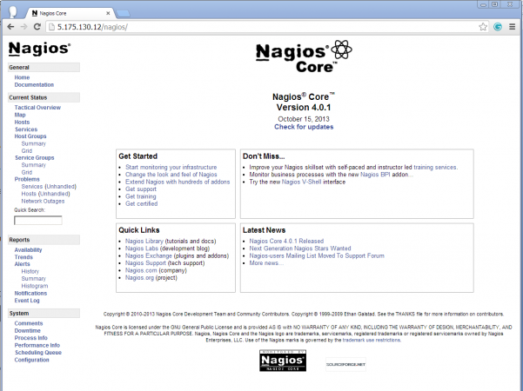](http://www.tecmint.com/wp-content/uploads/2013/10/Nagios-login.png)](http://www.tecmint.com/wp-content/uploads/2013/10/Nagios-login.png)

Nagios Web Interface

##### Host View

[[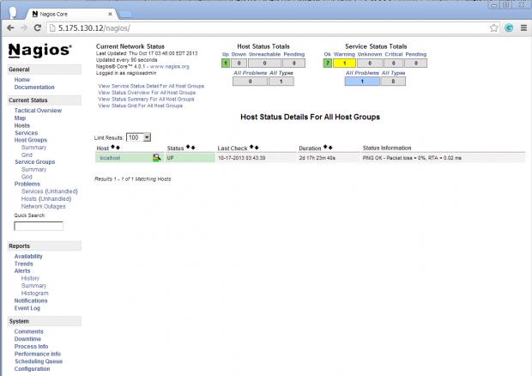](http://www.tecmint.com/wp-content/uploads/2013/10/Host-View.png)](http://www.tecmint.com/wp-content/uploads/2013/10/Host-View.png)

Nagios Host View

##### Nagios Overview

[[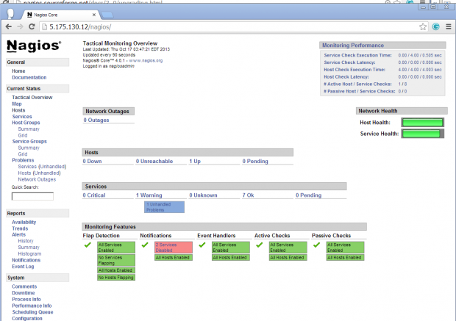](http://www.tecmint.com/wp-content/uploads/2013/10/Overview-Nagios.png)](http://www.tecmint.com/wp-content/uploads/2013/10/Overview-Nagios.png)

Nagios Overview

##### Service View

[[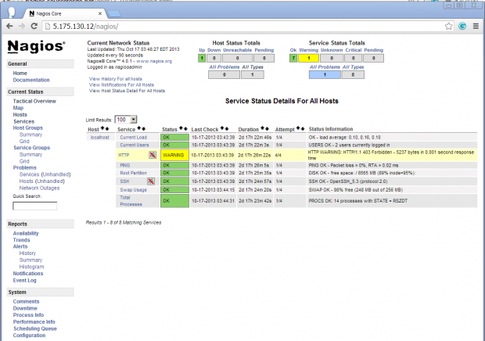](http://www.tecmint.com/wp-content/uploads/2013/10/View-Services.png)](http://www.tecmint.com/wp-content/uploads/2013/10/View-Services.png)

Nagios View Services

##### Process View

[[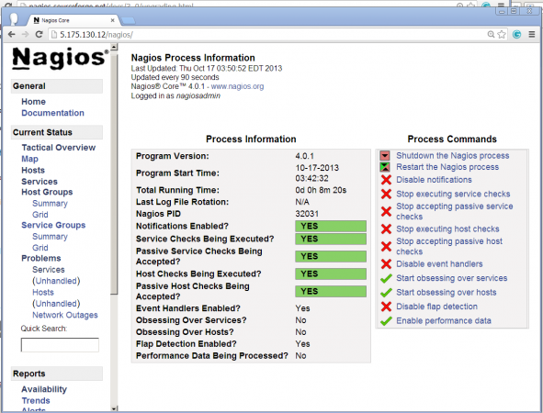](http://www.tecmint.com/wp-content/uploads/2013/10/Process-View.png)](http://www.tecmint.com/wp-content/uploads/2013/10/Process-View.png)

Process View

Congratulations! You’ve successfully installed and configured **Nagios** and its **Plugins**. You’ve just begin your journey into monitoring.

### Upgrade Nagios 3.x to Nagios 4.0.1

If you are already running an **older version of Nagios**, you can **upgrade** it anytime. To do so, you just need to download the latest tar archive of it and configure it as shown below.

[root@tecmint ]# service nagios stop

[root@tecmint ]# tar –zxvf nagios-4.0.1.tar.gz

[root@tecmint ]# cd nagios-4.0.1

[root@tecmint ]# ./configure

[root@tecmint ]# make all

[root@tecmint ]# make install

[root@tecmint ]# service nagios start

That’s it for now, in my upcoming articles, I will show you how to add **Linux**, **Windows**, **Printers**, **Switches** and **Devices** to Nagios monitoring Server. If you’re having any trouble while installing, please do contact us via **comments**. Till then stay tuned and connected to **Tecmint** and don’t forget to **Like** and **Share** us to spread around.